Report 1:

The search functionality is not working, even if the searched term exists on the site

Used device/Browser:

* Chrome (Version 114.0.5735.199 (Official Build) (64-bit)) on Windows 10

Steps to reproduce:

* Open the <http://www.gatesnfences.com/index.html> page
* Type something you want to search for in the search bar
* Click search button

Screenshot:

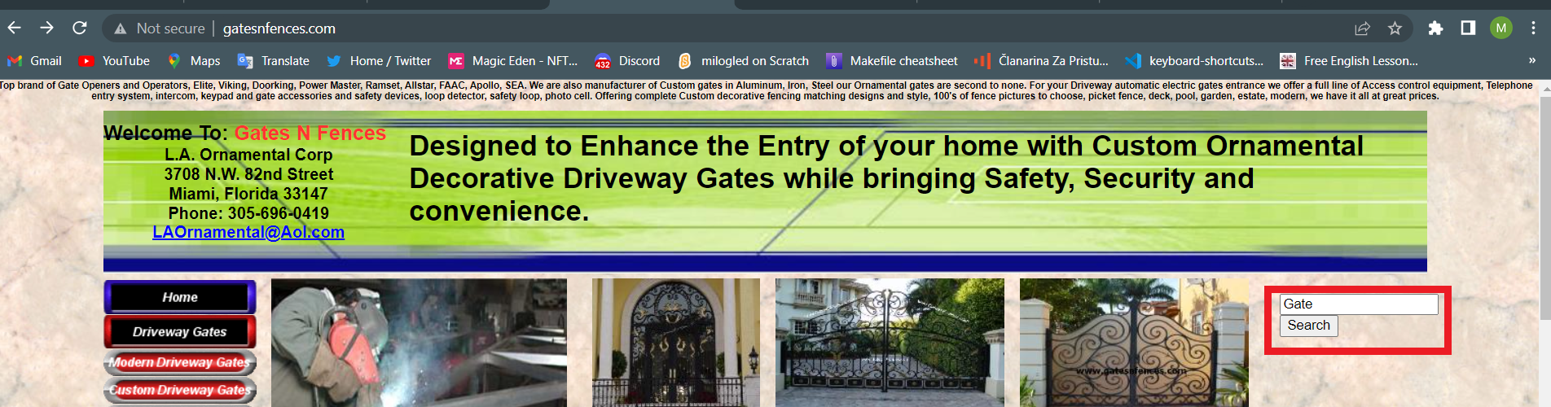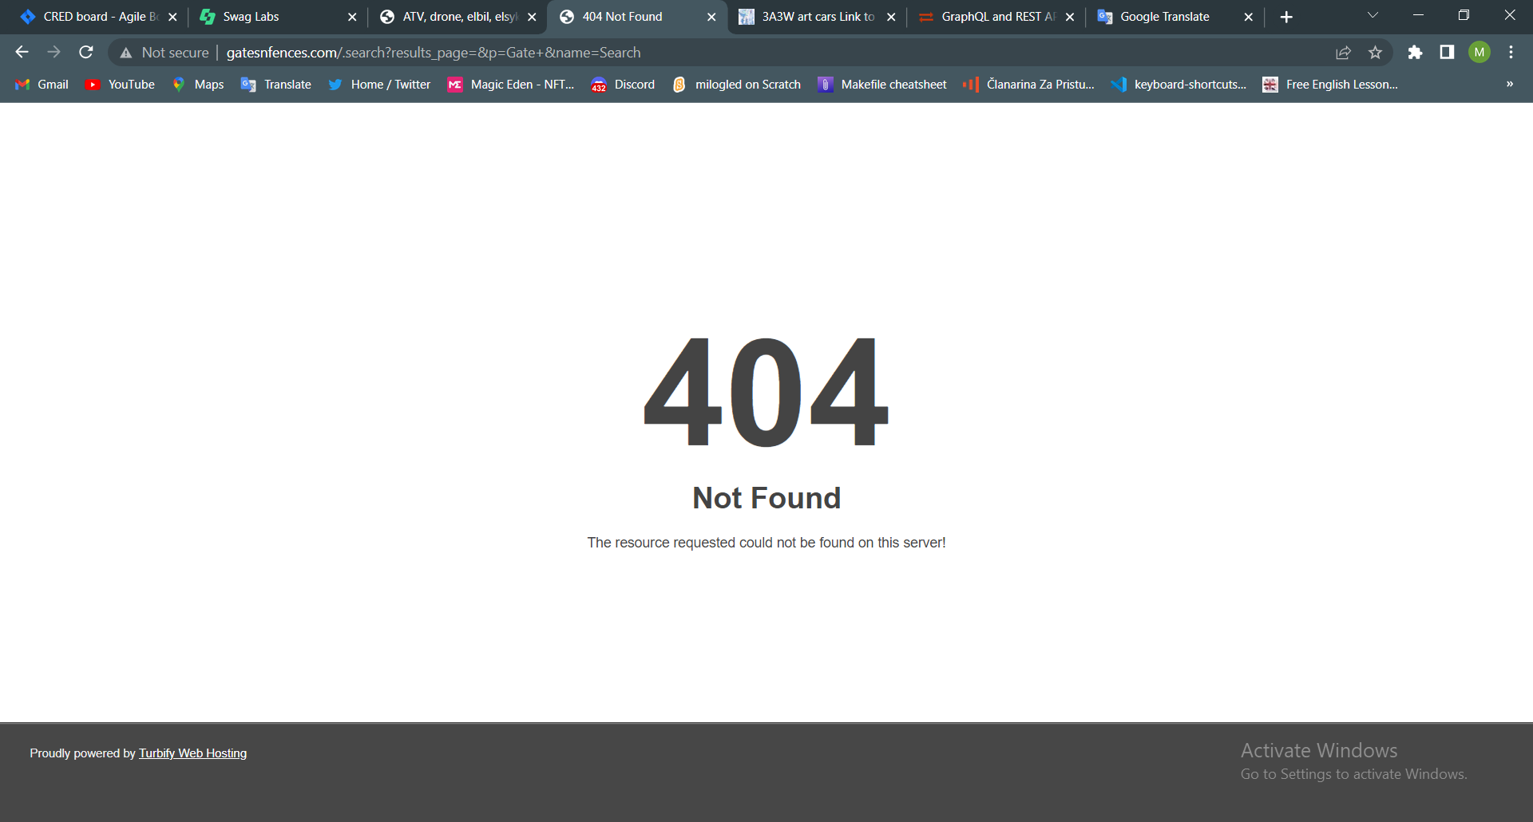

Report 2:

There is a broken image on the Home Page

Used device/Browser:

* Chrome (Version 114.0.5735.199 (Official Build) (64-bit)) on Windows 10

Steps to reproduce:

* Open the <http://www.gatesnfences.com/index.html> page
* Scroll to the bottom of the page

Screenshot:

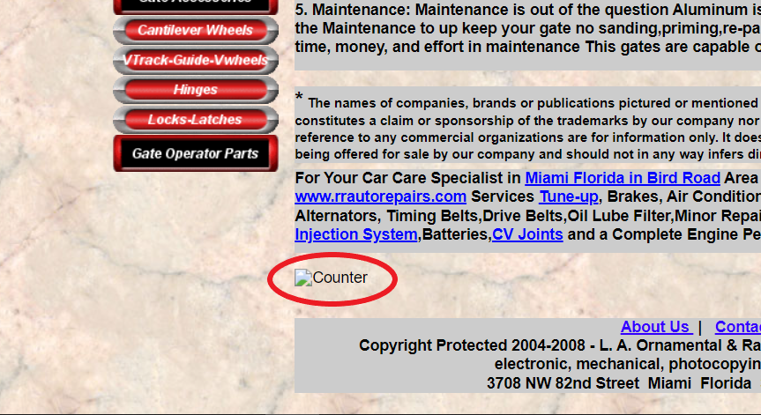

Report 3:

There is a group of dead links

Used device/Browser:

* Chrome (Version 114.0.5735.199 (Official Build) (64-bit)) on Windows 10

Steps to reproduce:

* Open the <http://www.gatesnfences.com/index.html> page
* Scroll to the bottom of the page

Screenshot:

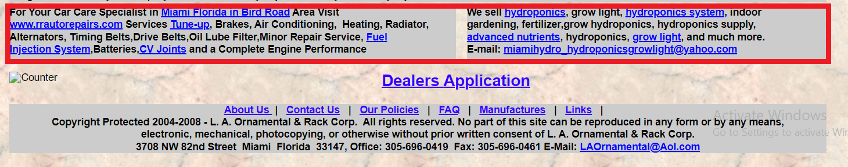

Here is the video ⬇️

<http://g.recordit.co/D6PtauirPy.gif>

Report 4:

It is possible to check every option in the “Contact Us” form, even if they are contradictory

Used device/Browser:

* Chrome (Version 114.0.5735.199 (Official Build) (64-bit)) on Windows 10

Steps to reproduce:

* Open the <http://www.gatesnfences.com/contact_us.htm> page
* Check every checkbox you find

Screenshot:

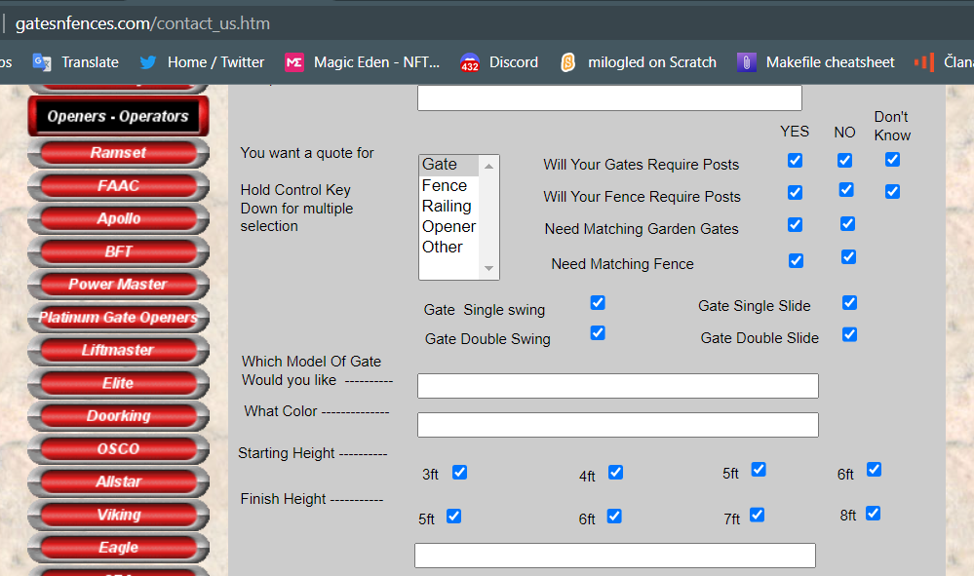

Report 5:

Some of the manufacturer's links are not working

Used device/Browser:

* Chrome (Version 114.0.5735.199 (Official Build) (64-bit)) on Windows 10

Steps to reproduce:

* Open the <http://www.gatesnfences.com/Manufacture-GateOpeners-AccessControls-Parts-SecuritySafetyEquipment-DrivewayGates.html> page
* Click the Power Master logo
* Click the Multi-Code logo

Screenshot:

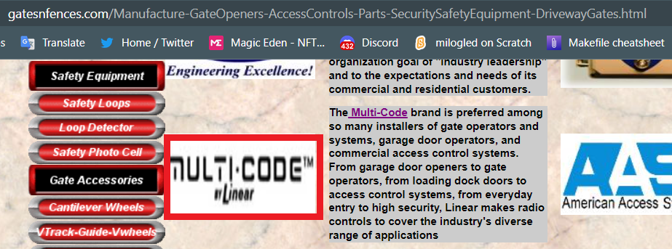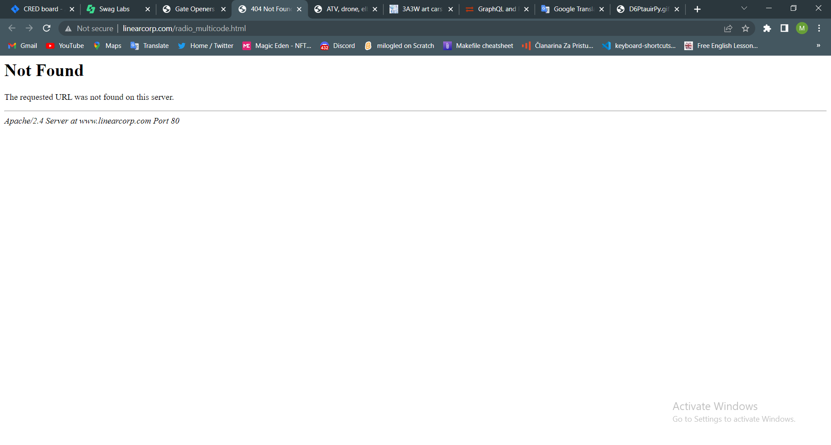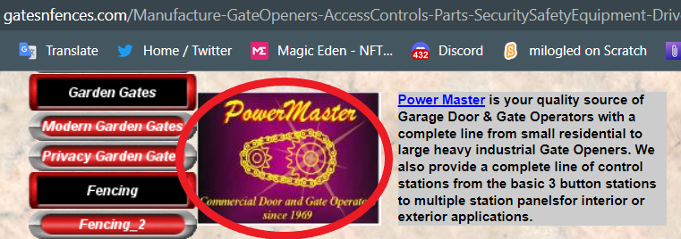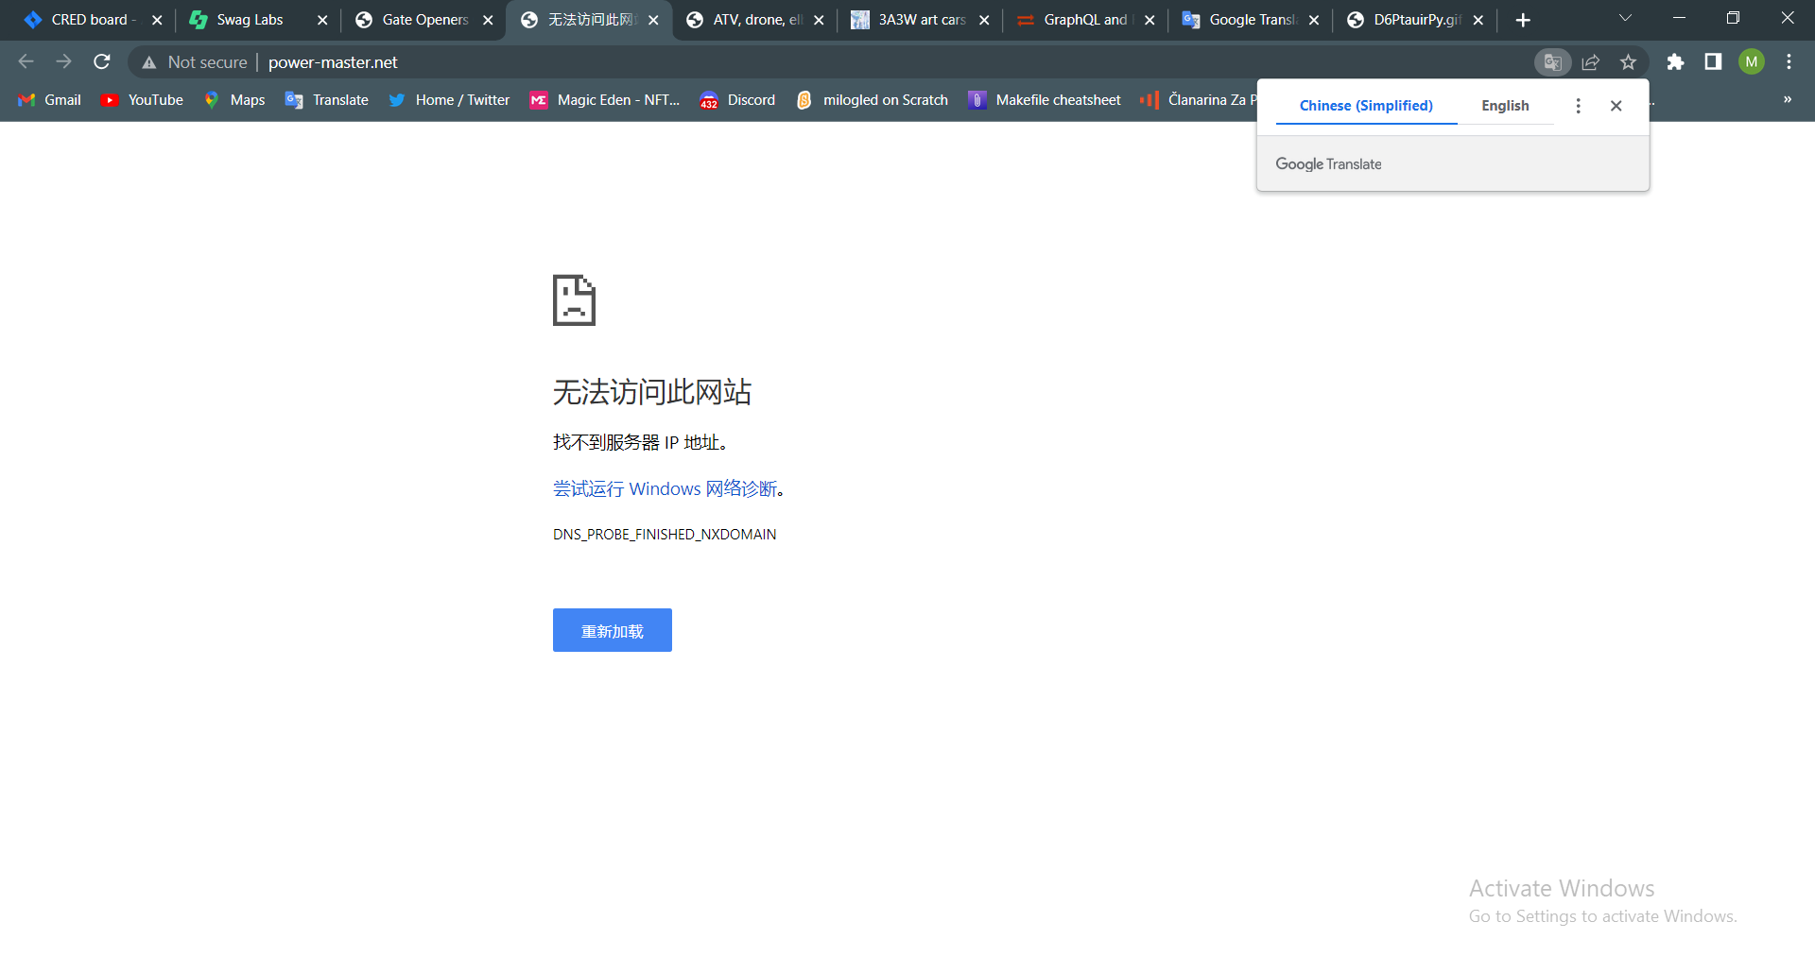

Report 6:

There are overlapping elements

Used device/Browser:

* Chrome (Version 114.0.5735.199 (Official Build) (64-bit)) on Windows 10

Steps to reproduce:

* Open the <http://www.gatesnfences.com/Long-Extended-Range-Transmitter.html>

page

* Scroll to the bottom of the page

Screenshot:

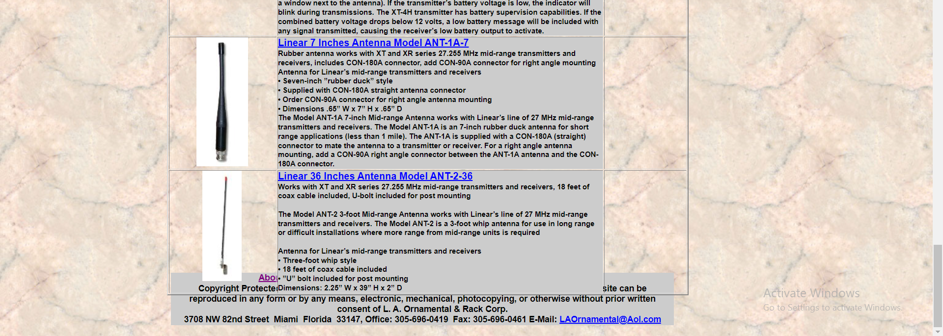

Report 7:

There are “Add To Cart” buttons with a scroll bar beside them

Used device/Browser:

* Chrome (Version 114.0.5735.199 (Official Build) (64-bit)) on Windows 10

Steps to reproduce:

* Open the <http://www.gatesnfences.com/Circuit-Boards/AllStar-Control-Boards-Main-Circuit-Logic-Boards.html>, or <http://www.gatesnfences.com/BFT-FAAC-SEA-Remote-Controls.html>

page

Screenshot:

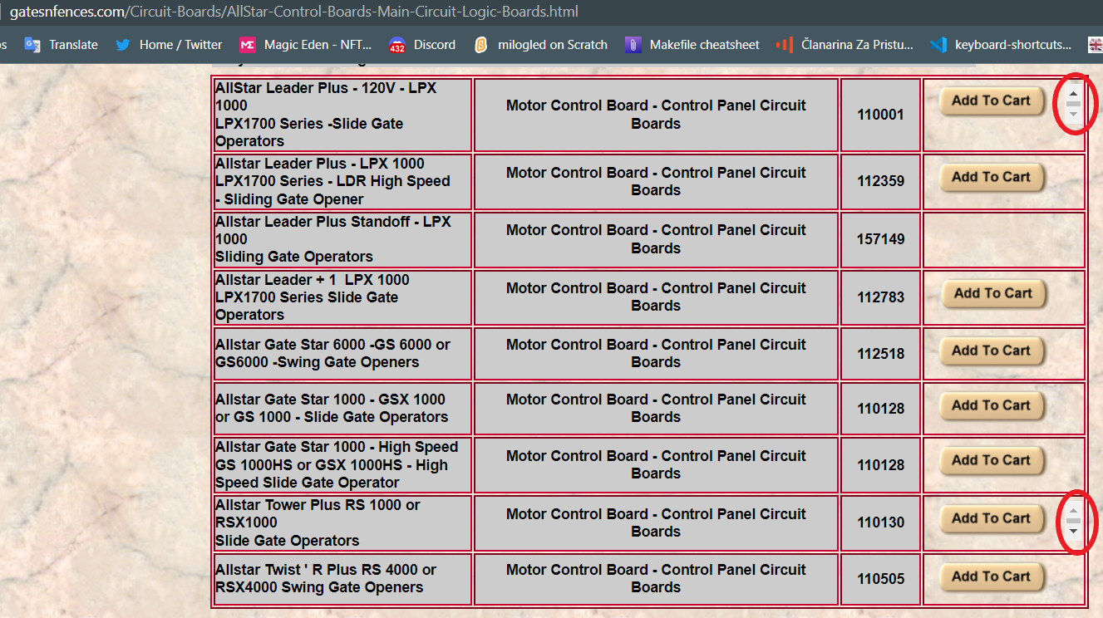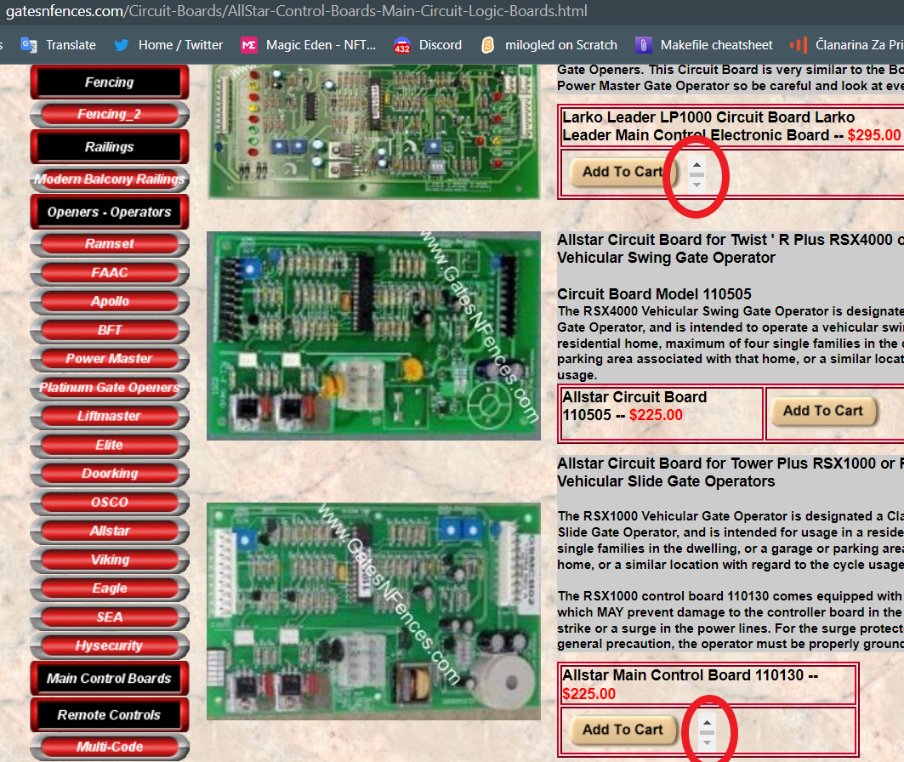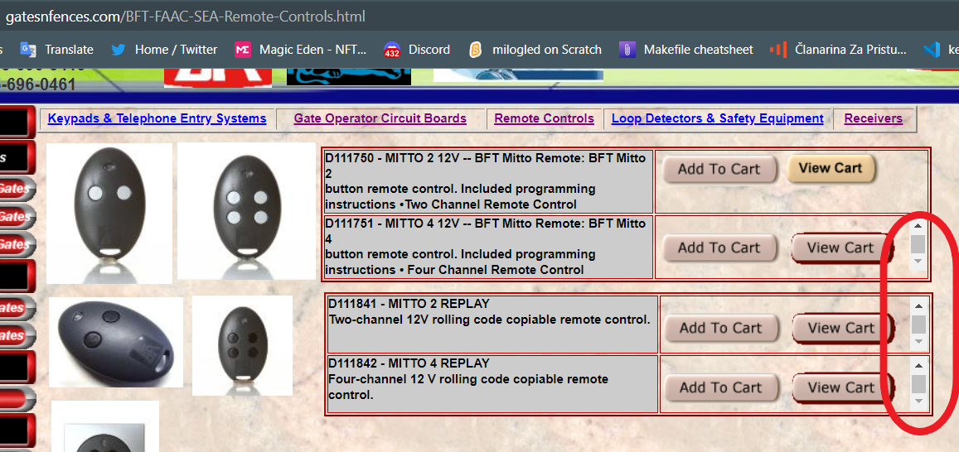

Report 8:

The Embedded YouTube video doesn't have the right dimensions, you must click the “Fullscreen” option to see it properly

Used device/Browser:

* Chrome (Version 114.0.5735.199 (Official Build) (64-bit)) on Windows 10

Steps to reproduce:

* Open the <http://www.gatesnfences.com/BFT-FAAC-SEA-Remote-Controls.html>

page

* Scroll to the embedded YouTube video

Screenshot:

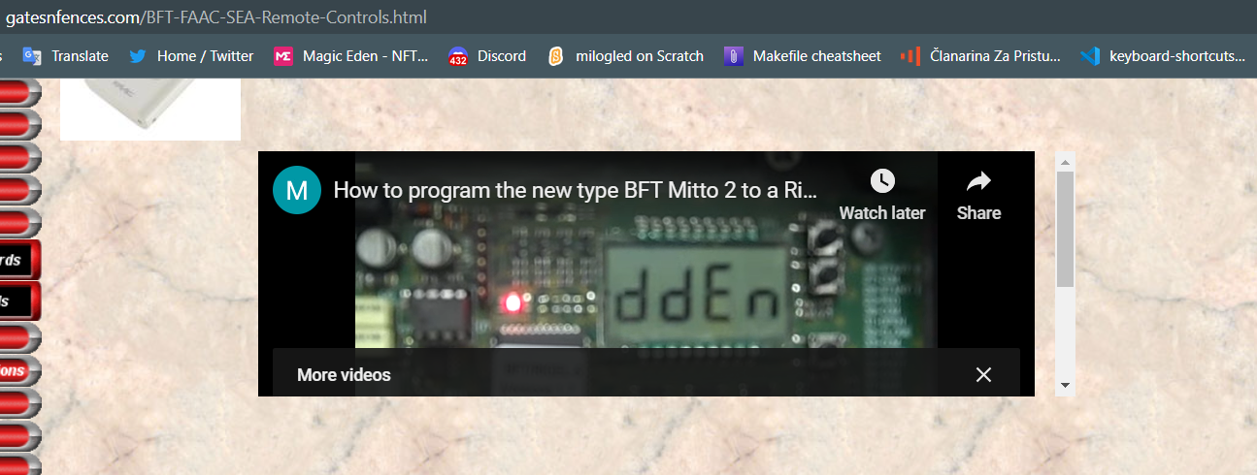

Report 9:

The link to the product manual does not work

Used device/Browser:

* Chrome (Version 114.0.5735.199 (Official Build) (64-bit)) on Windows 10

Steps to reproduce:

* Open the <http://www.gatesnfences.com/Access-Control-TelePhone-Entry-Intercom-Systems-Keypads/Sentex-Infinity-DI-Entry-System.html>

page

* Click the “Manual” link in the product description

Screenshot:

